 | Disabled American Veterans, Department of Maryland, Inc  Newsletter | Tel # 410-539-1310  Fax # 410-539-2106  Email Address: dav_md@verizon.net  3rd Quarter DEC  April 19, 2009  VFW Post 160  2597 Dorsey Road  Glen Burnie, MD 21060  65th Dept. Convention  May 27-30, 2009  Princess Royal Hotel  9100 Coastal Hwy  Ocean City, MD 21842  Year 2008-09 Issue 3  Dated: December. 2008  Editor: Cmdr Gregory Jones  Adj. Lisa Gregory  Publisher: B. Iafolla

DAV, Department of

Commander Message:

Hello Comrades,

As I sit and ponder what to say to you in my third article as Department Commander, I am reminded that tomorrow is not promised to any of us and we should be thankful for today. But, again as I did in my first article to you all, first before I get into my message to you, I want you to know that I am deeply saddened by the deaths of Past Department Commander Grant Acker and Past Department Commander Michael Piper. On this day, and all such days when we pause to remember, there are some essential lessons for us as well as all our citizens: Appreciate the blessings of freedom, recognize the power and virtue of sacrifice, and remember those who gave their lives to strengthen and preserve the invaluable gift of freedom. Grant and Michael, we will remember.

I know that depending on your particular religious faith, we all may see things a bit differently. None-the-less, I have been taught that death is a part of living and that death is not the end, but the beginning of everlasting life. And it is this belief that lifts my spirit each time I learn of the passing of one of our dear comrades. Too, Grant and Michael were extraordinary gentlemen who served this country well during extraordinary times. When I think of these two men, I am reminded of a quote by John Ruskin, who is best known for his work, during the 19th century, as an art critic, sage writer, and social critic, he said, “[t]he highest reward for a man's toil is not what he gets for it but what he becomes by it.” Michael and Grant dedicated their lives to helping veterans. I believe their deeds will live forever in the annals of the Maryland Department of the Disabled American Veterans, and in our hearts. May God bless both of them and the family members they left behind. May you both have fair winds and following seas.

As the saying goes, Spring has sprung. Spring to me is symbolic of new beginnings. So with that in mind I wish to briefly address the newly elected and installed chapter officers. You all were elected or appointed because of your executive and leadership ability and as we are in the mist of a deep recession, I simply ask you to be good stewards while at the same time do what is right by taking care of our veterans. You should also do your best to motivate and inspire your membership, and, please do not forget the Disabled American Veterans Auxiliary.
During the coming membership year, the Department and Chapters alike will continue to be faced with the problems of dealing with diminishing resources. We should be mindful of our purpose and we need to ensure we focus and capitalize on our ability to plan realistically, and to meet some of our toughest challenges head-on. Our membership and the American people want us to continue to build better lives for those who have borne the battle. Remember what President Theodore Roosevelt said, “Power undirected by high purpose spells calamity; and high purpose by itself is utterly useless if the power to put it into effect is lacking.”
Again I want to leave you with a quote from President John F. Kennedy. President Kennedy said, “[e]fforts and courage are not enough without purpose and direction.”

Yours, in comradeship,

See you at the 3rd DEC meeting in Glen Burnie, Maryland on April 19, 2009. Be there or be square.

J

Gregory N. Jones
Department Commander

MAY THERE BE
PEACE IN THE WORLD

Happy Easter
And Passover

IMPORTANT PHONE NUMBERS

Nat’l. Hdqrs., DAV (877)426-2838
DAV, Dept. of MD (410)539-1310
(800)328-6953
Fax: (410)539-2106
NSO Office – Baltimore (410)230-4440
NSO Office –Wash., DC (202)530-9261
VA Regional Office –Balto. (410)230-4500
(800)827-1000
VA Regional Office – DC (202)530-9260
Dept. of Veterans Affairs (800)446-4926
VAMHCS – Baltimore 1-800-463-6295
DAV Transportation (410)605-7000
HSC, Tony Bettick (Ext. 6733)
BRECC (410)605-7000
VAMHCS – Perry Point 1-800-949-1003
DAV Transportation (410)642-2411
HSC, Woodrow L. Shenk (Ext. 5384)
VAMC – Cambridge 1-877-864-9611
VAMC – Cumberland (301)724-0061
VAMC - Fort Howard 1-800-351-8387
DAV Transportation (410)477-7050
HSC, Franklin Martin (Ext. 7019)
VAMC – Greenbelt (301)345-2463
VAMC – Loch Raven 1-800-463-6295
VAMC – Charlotte Hall (301)884-7102
1-800-522-8387
VAMC – Hagerstown (301)665-1462
VAMC – Glen Burnie
DAV Transportation (410)590-4140
HSC, Tommie Hawkins (Ext. 4221)
VAMC – Pocomoke 1-866-441-0287
VAMC – Washington, DC (202)745-8100
VAMC - Wilmington, DE (302)633-5414
VAMC – Martinsburg, WV (304)263-0811
VA Homeless Shelter (410)605-7264
McVets (410)576-9626

Telephone Care Line: To schedule Urgent Care Appt. call 1-800-865-2441. Veterans who need to schedule a same day appointment can call the Telephone Care Line Monday thru Friday, between 7:30 a.m. and 5 p.m. by dialing 1-800-865-2441.

Prescription Refill Line: 1-800-463-6295, ext 7395. Have SS# & Prescription # ready, press option “2”.

Prescription Refills Online: To access the VA online Prescription Refill Service, you need to be registered user of My Healtheet. To become a registered user, visit My HealtheVet website at www.myhealth.va.gov. For questions about how to complete the registration process, call the My HealtheVet Coordinator for the VA Maryland Health Care System at 1-800-463-6295, ext. 7045

Appointment Call Center: To schedule, change, cancel or confirm a clinic appointment at any facility, call Monday thru Friday 7:30 a.m. to 5 p.m. at 1-800-463-6295, Ext. 7333.

Suicide Prevention Hotline: call the VA’s 24 hour national suicide prevention hotline at 1-800-773-talk (8255), Press “1” for veterans.

Billing Information: If you have a question about a bill you received from the VA Maryland Health Care System, please call the VA Health Revenue Center at 1-866-393-0006, Monday thru Friday, from 8 a.m. to 8 p.m.

Automated Appointment Line – To check on your future appointments or to cancel appointments throughout the VA Maryland Health Care System 24 hours a day, 7 days a week, please call the Automated Appointment Line at 1-800-463-6295, ext 7395 and press option “1.” Please have your Social Security number ready when calling.

VA Health Care Eligibility and Enrollment: For information about VA Health Care eligibility or how to enroll for VA health care, please contact the Enrollment Center for the VA Maryland Health Care System Monday through Friday, from 8 a.m. to 4:30 p.m., at 1-800-463-6295 ext 7324.

Services For Returning Veterans: For information about the health care services available for veterans returning from Operation Enduring Freedom (OEF) and Operation Iraqi Freedom (OIF) or for information about how to enroll for VA health, please contact the OEF/OIF Program Manager for the VA Maryland Health Care System at 1-800-463-6295, ext. 7259

Long-Term Care Information Line: Veterans and their family members who have questions about nursing home and long-term care programs and services available through the VA Maryland Health Care System can call the Long-Term Care Information Line at 1-800-949-1003 ext. 1121

Patient Advocates: If you have a problem receiving health care services, or you have a concern or compliment about the customer service provided by any of our staff members, please contact one of our patient advocates:
Baltimore VAMC 1-800-463-6295, Ext. 7099
Perry Pt. VAMC 1-800-949-1003, Ext. 5097
Baltimore VA Rehabilitation & Extended Care
Center and all VA Outpatient Clinics call,
1-800-463-6295, Ext. 7542

VA Benefits (Other than Health Care): For information about VA disability, education, home loan, life insurance, vocational rehabilitation, employment, and survivor’s and dependent’s benefits, please call the Veterans Benefits Information Line 24 hours a day, 7 days a week, at 1-800-827-1000.

For help with Benefits, Claims and Representation: Call the DAV National Service Organization at 410-230-4440, and ask to speak to an NSO – Representative. Please have your Social Security Number, Claim Number , plus any VA Paperwork that you are calling about at hand when you call.

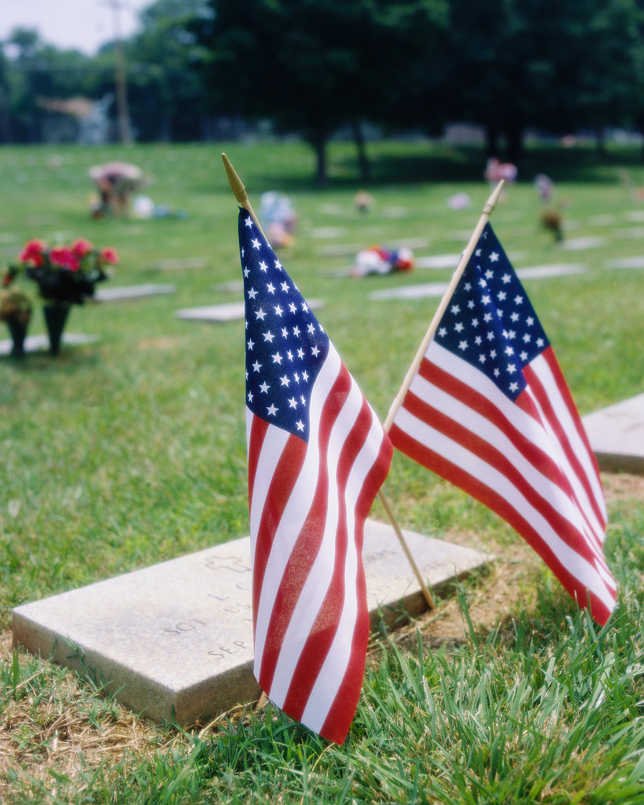
CEMETERY & MEMORIAL PROGRAMS
Christopher Piscitelli, Director
1122 Sunrise Beach Road
Crownsville, MD 21032
Anne Arundel County
410-923-6981

CHELTENHAM VETERANS CEMETERY
Martin F. Fahey, Superintendent
Cheltenham
Prince George’s County
301-372-6398

CROWNSVILLE VETERANS CEMETERY
Virginia “Pat” Ritter
Superintendent
Crownsville
Anne Arundel County
410-987-6320

EASTERN SHORE VETERANS CEMETERY
Bruce W. Webster, Superintendent
Hurlock
Dorchester County
410-943-3420
Toll free – 866-497-3684

GARRISON FOREST
VETERANS CEMETERY
Kenneth McKisset, Superintendent
Owings Mills
Baltimore County
410-363-6090

ROCKY GAP VETERANS CEMETERY
Ronald B. Platt, Superintendent
Allegany County
301-777-2185

MEMORIALS
Patrick M. Tracy, Superintendent
Baltimore, MD
410-354-3550

WAR MEMORIAL BUILDING
(WWI & II records, service metals)
Douglas W. Henley
Executive Director
Baltimore
410-396-8013
UPCOMING EVENTS
(DATES TO REMEMBER)


01 St. Mary’s Chapter/Unit #26
Installation/Dinner 6:00 PM

03 3rd DEC Packets reports & Book Ads are due
in to Department Office.

05 Palm Sunday

08 Ernie Pyle Chapter/Unit #4 Installation 6PM

09 Paul L. Thompson Memorial Chapter/Unit #1
Installation 7:30 PM

12 Easter

14 M.R. “Sarge” Wareheim, Chapter 33
Installation 7PM

16 Edward T. Conroy, Chapter #9 Installation -
Fishmans Inn, 6PM

PFC J.C. DeMarr, Jr. Chapter #36 Installation
7PM

18 Cecil County Chapter #28 Installation 12 PM

19 3rd DEC Meeting – VFW Post 160 in Glen Burnie, Maryland – 1PM

20 Towson, Chapter/Unit #18 Installation 7PM

21 Old Glory Chapter/Unit #22 Installation 7:30PM

23 Washington & Lee Chapter #5 Installation –
8 PM

25 Veteran Muster – American Legion Post 11
Frederick, Maryland

8 Convention DEC Packet Reports due in to
the Department Office

28-30 65th Department Convention

MARK YOUR CALENDARS

3rd DEC Meeting
April 19, 2009, 1PM
VFW Post 160
2597 Dorsey Road
Glen Burnie, MD 21060
Tel: 410-766-9802

All DEC Reports are due in the Dept. Office NLT 4/3/09, you may send them by fax 410-539-2106 or email to dav_md@verizon.net or mail.

65th Department Convention
May 27-30, 2009
Princess Royal Oceanfront Hotel & Conference Center
9100 Coastal Highway
Ocean City, MD 21842
Tele: 1-800-476-9253 or 410-524-2544

All Reservations must be made NLT April 3rd, 2009 in order to get discounted group rate. The discounted room rate is $109.00 per night for Poolside and Ocean view, you must phone in to get the discount rate, doing on-line reservations, you will be charged full rate. To make your reservations, please call the Princess Royale Reservation desk at 1-800- 476-9253 or 410-524-2544 ASAP. Call the Hotel if you do not received your confirmation.

All DEC Reports are due in the Dept. Office NLT 5/8/09, you may send them by fax 410-539-2106 or email to dav_md@verizon.net or mail.

65th Annual Convention

DISABLED AMERICAN VETERANS
DEPARTMENT OF MARYLAND, INC.

(TENTATIVE AGENDA)

Wednesday, May 27, 2009
1 – 5 pm Fishing Trip Make arrangements at Pier
1 – 4 pm Registration Promenade

Thursday, May 28, 2009
8 – 4 p.m. Registration Promenade Lobby
9:30 – 12 pm Joint Opening Session/Memorial Service Palmetto 3, 4, 5
9 – 4 pm VA Health Screening Palmetto 1
1 – 5 pm Seminars &Training Palmetto 3, 4
- 1PM - Women Veterans Benefits Session
- 2PM - NSO – Question $ Answer Session
- 3PM - Roberts Rules Training
- 4PM - Forget-Me-Not /Fundraising Session
- 5PM - Homeless Veterans Presentation

Friday, May 29, 2009
7:30 – 9 am Vice Commander’s Breakfast Schooners
8 – 4 pm Registration Promenade Lobby
9:00 – 11:30 am Business Session Palmetto 4-5
11:45 – 1:30 pm Forget-Me-Not Luncheon Caribe D&E (Downstairs)
2 – 5 pm Business Session Palmetto 4-5
7 – 11 pm DAV/DAVA CMDR’S Reception Suite 227/229/Atrium

Saturday, May 30, 2009
8 – 9 am PDC Breakfast Schooners
8 – 9:45 am Registration Promenade Lobby
10 – 1 pm Business Session (Election of Officers)
Palmetto 4-5
6-9:30 pm Cocktail Hour (Cash Bar)
Palmetto Ballroom 1-2-3
7-10 pm Convention Banquet Palmetto Ballroom 1-2-3

Sunday, May 31, 2009

11:00 am Check out-time—have a safe trip home

64th Annual Convention

DISABLED AMERICAN VETERANS AUXILIARY
DEPARTMENT OF MARYLAND, INC.

(TENTATIVE AGENDA)

Wednesday, May 27, 2009
2:00 – 4:00 pm Registration of Delegates and Alternates
Promenade

Thursday, May 28, 2009
8:00-9:00 pm Registration of Delegates and Alternates
Promenade
9:00-4:00 pm VA Health Screening Palmetto 1
9:30-Noon Memorial Service and Joint Opening Session
Palmetto 3, 4, 5
1:30-4:00 pm Auxiliary Business Session Palmetto 2
4:00-5:00 pm Registration of Delegates and Alternates
Promenade

Friday, May 29, 2009
8:00-9:00 pm Registration of Delegates and Alternates
Promenade
9:30-11:00 am Auxiliary Business Session Palmetto 2
11:30-1:30 pm Forget-Me-Not Luncheon
Caribe D & E (Downstairs)
2:00-4:00 pm Auxiliary Business Session Palmetto 2
4:00 – 5:00 pm Registration of Delegates and Alternates
Promenade
7-11 pm DAV/DAVA Commanders Reception
Suite 227/229/Atrium

Saturday, May 30, 2009
8:00 – 9:15 am PSC Auxiliary Breakfast Aruba
8:00-9:00 am Registration of Delegates and Alternates
Promenade
9:30 am – 1pm Business Session, Election/Installation of
Officers Palmetto 2
6:00-7:00 pm Cocktail Hour (Cash Bar)
Palmetto 1, 2, 3
7:00-10:00 pm Convention Banquet & Installation of
Officers Palmetto 1, 2, 3

Sunday, May 31, 2009
11:00 am Check out-time—have a safe trip home

Lisa M. Gregory, Dept. Adjutant

First and foremost I want to congratulate each of you for attaining the state membership goal. It is your hard work and effort that made this happen, for your chapter and the state.
Now it’s time to talk BASEBALL. The schedule for the upcoming games is included and we have another year of great games, both Minor and Major league. This is a great opportunity to share an event with those who otherwise may not be able to. If you would like to purchase tickets for hospitalized veterans please contact me to work out the details. Several chapters have already contributed to this great night out!!
I know that many chapters are having their installation ceremonies in the upcoming weeks, so please remember to submit your Chapter Officer Forms to the department. Please be sure to fill them out completely and please include at least one email address for a chapter officer. Email has been a great resource for the Department to get information out as quick as possible to the chapters. If one person has contact with the department they are able to spread the word faster rather than waiting for an upcoming meeting to share information.
Give your new chapter officers the courtesy and assistance they need to get their job done. Please be sure to transfer all chapter paperwork to the new officers. This is important, especially when it comes to completing the Annual Finance Report.
One last note I’d like to share with all of you. If you have been looking to become involved with the welcome home ceremonies for our returning service members at the airport here is a contact website and phone number to assist your efforts. Go to www.owhmd.org or call 410-630-1555 for more information on how to take part in this wonderful event.
Thank you for everything you do for our veterans!

Lisa Gregory
Adjutant

It’s Baseball Time!!!!

The Department of Maryland will again be participating in several DAV Night at the Ballpark Events. Listed is a schedule of games to date. For tickets contact the Department at 410-539-1310.

This is also a great service project for your Chapter. Your chapter can purchase group tickets to donate to the hospitals, and other charitable organizations and share this event with those who may not be able to get out on a daily basis.

GAME DATES & TIMES

May 16th – Bowie Baysox vs. Erie Seawolves, Game time 7:05 p.m. Tickets are $6. There is special gift for Chapter selling the most tickets.

June 23rd – Aberdeen Ironbirds vs. Staten Island Yankees, Game time 7:05 p.m. Tickets are $10 and include a free cap.

July 11th – Baltimore Orioles vs. Toronto Bluejays, Game time 7:05 p.m. Tickets are $6. There are Lower Reserve Centerfield seats.

July 13th - Frederick Keys vs. Kingston Indians
Game time 7 p.m. Tickets are $2.50. Kids eat free.

August 9th – Washington Nationals vs. Arizona Diamondbacks, Game time 1:35 p.m. Tickets are $10.00 for lower right field

Come out and watch the Commander try his pitching arm!!!

DEPT. SVC AND JR VICE’S

Dept. SVC – Robert L. Wilcoxen

Here we go again with an up date of some of my activities since the December Department news letter. I have traveled quite a bit still meeting a lot of the Chapter’s and Comrades in the State. Below is a sampling of the events that I have attended. I thank you all for the hospitality that you have shown to me.

November 2008

29 - Chapter Service Officer Training at Charlotte
Hall Library, Charlotte Hall, MD

December 2008

1st - Chapter #3 Christmas Party, Annapolis, MD
3rd - Chapter #26 Christmas Party, California, MD
4th - Chapter #13 Christmas Party, Glen Burnie,
MD
5th-7th Attended 6th District NEC Mid-Year
Meeting, Charlottesville, VA
9th - Chapter #33 Christmas Party, Odenton, MD
10th -Chapter #4 Christmas Party, Wheaton, MD
11th - Chapter #1 Christmas Party, and worked at
Department Office in Baltimore, MD
17th - Worked at Department office and attended
Department Christmas Party
17th - Attended JVC meeting at Bowie, MD
18th - Attended a special meeting at Chapter 31,
And installed the new Officers

January 2009

4th-8th Attended the Department Mid-Winter
Conference at Ocean City, MD
21st - Attended JVC meeting at Bowie, MD
22nd - Worked at the Department Office
24th- Attended the Veterans Muster at Dundalk,
MD

February 2009

4th- Visit Chapter #26 as SVC
5th -Worked at Department Office
7th -Attended the Maryland Service Foundation
Meeting at Bowie, MD
10th - Official Visit to Ch#33 as SVC
11th - Official Visit to Ch#4 as SVC
12th - Worked at Department Office
12th - Official Visit to Ch#23 as SVC
17th -Official Visit to Ch#22 as SVC
19th -Worked at Department Office
21st - Attended Veterans Muster at American
Legion Post #64 in Salisbury, MD
21st -25th Attended the National Mid-Winter
Conference Arlington, VA
23rd - Attended JVC meeting at Bowie, MD
26th - Attended Veterans Information Seminar at
Williamsport, MD with the NSO, and 4th Jr.
Vice Commander.

March 2009

7th - Attended Chapter #7 as Installing Officer
15th -Attended Chapter #21 Installation of Officers
18th - Attended JVC at Bowie, MD
19th - Official Visit to Chapter #9 as SVC

Still have a lot more to do the rest of this month and next. I hope to see more of you in the near future.

Everyone is working very hard keeping their chapter’s together and encouraging new membership.

1ST JVC – Flip P. Micocci

See NSO section

2nd JVC – Gary Roundtree

Greetings my fellow Comrades, It has been a pleasure to serve you and to represent the DAV over the course of this year. I have visited the following Chapters assigned to me and they are as follows: Chapter #9, Chapter #15, Chapter #28, Chapter #30, Chapter #31 and Chapter #34.
The Maryland Department of Veterans Affairs [MDVA] has hosting information seminars and forums for veterans and families to educate veterans about benefits and services offered to them. Various Veterans Organizations attend these Muster in every county in Maryland. I have attended theses musters to assist our veterans with claims and share to information about benefits available to them and their families. On March 14, 2009 a muster was held at Howard County Community College and I assisted veterans with claims and benefit information, and currently assisting a veteran from the state of Fla. Last year I became a CRSC and TSGLI Ambassador with the U.S. Department of the Army to further help Retirees Veterans.
CRSC and TSGLI has a Bi- monthly Training Call session each month for ambassadors all over the country. [March 11 and May 13, 2009 CRSC] and [March 18 and May 20, 2009 TSGLI]. I am honored to announce my appointment as Chaplain for the Marine Corps League, Baltimore Detachment #565 that took place at our February Meeting 2009. Since being a Delegate for the Joint Veterans Committee of Maryland, INC., I have been present at every meeting except for the meeting in October 2008 due to an out of town engagement with the Department of Veterans Affairs Chaplains Association [NBCA] under the leadership of President Michael L. McCoy, Sr. of the Military Chaplains Association of the United States of America and Department of Veteran Affairs [NBCA] in Hampton, Virginia.
I have also attended NARFE'S 11th BIENNIAL LEGISLATIVE TRAINING CONFERENCE in Arlington, VA from March 7, 2009 till March 10, 2009, and will be attending the Department of Veterans Affairs Chaplains Executive Board Meeting March 26-29 2009 in Hampton Virginia.
In closing, I want thank every Department staff, Chapter commanders, adjutants and comrades and volunteers. GOD Bless!
3rd JVC – Jacinta McCreary

She has nothing to report at this time.

4th JVC – Mike Sater

Who did you elect? Mike Maddog Sater, Vietnam 1968-1969, 31st Engineers 20th Engineering Battalion, Blackhorse Base Camp Vietnam. Home for 11th Armor Calvary was transferred to 86th Engineer Dong Tan, Home of Ninth Infantry. Wounded February 1969; recovery Camp Zamia, Japan transferred to Kimbrough Army Hospital, Fort George G Meade, Md. Reassigned to 6th Armor Calvary Fort George G Meade, Maryland, Discharged in 1970.

I am married to Barbara Sater, 38 Years with two daughters Holly and Heather. Retired production supervisor from General Motors Baltimore how long I remain retired will depend on the future of General Motors.

I have been a member of the D.A.V. since 1970 and a life member since 1985. I became active in chapter #22 after I retired and was elected Commander after Commander A. Houck had personal family problems that forced him to not seek commander again so he could take care of his spouse.

I was very honored that Department officers saw fit to offer me the opportunity to serve in a State level capacity and that the membership elected me in. I will do my best to not let the department and my Comrades down.

Since my election in January 2009 I have been learning the duties of Vice Commander. There’s a lot to learn and do. I will continue to visit as many chapters as I can before the May Convention.

I would like to thank all the chapters and units for their help and support.

I especially want to thank the Officers and Comrades of Chapter # 22 and the Auxiliary who have stepped up to the Challenge of what will be the FUTURE of the D.A.V.

Dept of Maryland – Admin Asst.
(Cookie) B. Iafolla

Happy Palm Sunday & Easter

Chapters/Units: please keep the Department informed:

- Officer Reports are due into the Department 10 days after Election and Installation of Officers; please make sure you fill out all information needed on forms, especially Phone/fax # and Email Addresses. Please list Membership Chair and their phone number, also please list any CSO’s for your chapter with their phone numbers. Note: any changes to Officer Report Form must be sent in immediately on a New Officer Report Form. If you need Chapter Officer Report Form, Call the Department Office at 410-539-1310.

- Do we have your current email address? If not, call the Dept. Office or send us an email with your email address, this way we can keep you informed of happenings within the Department, Chapters, Units and State of Maryland. Also, please inform the Department of any address change, telephone number or email changes.

- Please let us know of members of your Chapter or Unit who are ill or hospitalized, or pass away, we would like to send them or their family a card and to let other members of DAV/ DAVA know and place their names on Deceased List and in the Newsletter.

- If you’re not getting DAV National Magazine, call National Headquarters at 1-877-426-2838 Membership (Ext. 3323).

- If the Department can help you in any way, please contact me, I am more than willing to help where I can. For example, for membership, have you check chapter 6 membership list for possible members in your area? If not do so and if you don’t have the capability to do so, contact me by email, giving me a list of zip codes in your area and I will be happy to send you Chapter 6 members list for those zip codes so you can send out a letter to those members to try to get members for your chapters. This should be done by the Chapter Adjutant or Chapter Membership Chair, so I don’t get double requests.

Happy Passover

Message from Dept. Chaplain

It is possible to give away and become richer! It is also possible to hold on too tightly and lose everything. Yes, the liberal man shall be rich! By watering others, he waters himself.
Proverbs 11:24-25
The following short story is one that I thought was very appropriate to share with my fellow Disabled American Veterans. Each of us should strive to “grow good corn” as we go about the business of helping veterans. Always remember that I am just a phone call away . . . 301-996-5305. God Bless you all!
Grow Good Corn
Author Unknown
There once was a farmer who grew award-winning corn. Each year he entered his corn in the state fair where it won a blue ribbon. One year a newspaper reporter interviewed him and learned something interesting about how he grew it. The reporter discovered that the farmer shared his seed corn with his neighbors.
“How can you afford to share your best seed corn with your neighbors when they are entering corn in competition with yours each year?” the reporter asked.
“Why sir,” said the farmer, “Didn’t you know? The wind picks up pollen from the ripening corn and swirls it from field to field. If my neighbors grow inferior corn, cross-pollination will steadily degrade the quality of my corn. If I am to grow good corn, I must help my neighbors grow good corn.”
He is very much aware of the connectedness of life. His corn cannot improve unless his neighbor’s corn also improves.
So it is with our lives. Those who choose to live in peace must help their neighbors to live in peace. Those who choose to live well must help others to live well, for the value of a life is measured by the lives it touches. And those who choose to be happy must help others to find happiness, for the welfare of each is bound up with the welfare of all.
The lesson for each of us in this: if we are to grow good corn, we must help our neighbors grow good corn.



FOR THOSE WHO ARE ILL, IN HOSPITALS OR RECOVERING FROM AN ILLESS OR SURGERY, YOU ARE IN OUR THOUGHTS & PRAYERS…

DAV

Chapter 3 Toni King

Chapter 7 PDC Bill Meyers

Chapter 13 Grant Acker (PDC)
Tommie Hawkins
Frank Martin

Chapter14 Richard Robinson
Victor Barnhart
Basil Kukn
Fred Wisherd
Wayne Alter
Dale Everett
Stanley Jones
Clarence Schroyer
Gary Hovermale

Chapter 17 Maurice Alexander

Chapter 23 Joseph Ranselle

Chapter 26 Peter Rieser
Robert Young
Thomas Dennee
Vincent Thrasher
Charlie Hugg

Chapter 30 Dennis W. Story

Chapter 31 Webster Dorsey

Chapter 33 Michael Minardi
Skip McGehee
Rodney Burr
Neil Thompson’s wife
Brian Lewis

DAVA
Unit 17 Hazel Meyers (PSC)

Unit 22 Elizabeth Houck

Unit 26 Rebecca Dennee
Terri Lackner
Elise Bowman
Lucy DeLuzio

To all the other DAV/DAVA Members who are not listed above that are ill, or who is/was hospitalized and is in the recovery stage.

When you are feeling kind of out of sorts, and it seems like there is a nasty cloud hanging over you. Whether it be aches or pains from surgery, fever, chills, upset stomach and headaches from colds or flu; know behind that nasty cloud, is the Sun….to brighten your day. The DAV & DAVA wishes you a brighter day and hopes you feel better real soon.

THE DAV/DAVA NEEDS YOU…

“May our Comrades and Friends
Rest In Peace”
YEAR 2008-2009
DAV

Chapter #01 Otis Lee, Sr.
Collin Branch
Arthur Lewis

Chapter #3 Talmadge L. Cooke
Joseph Ross Darnell, Sr.
Robert L. Garrison Jr.
Jon Holden
Gerald J. Holeman
Clarence I. Johnson
Henry Koellein, Jr.
James H. Mackey
Edward J. Markowski
Bernard Webster Moulton
Watson E. Mowbray
James W. Pierce
John W. Ripley
Ronald R. Schultz
Elbert Eugene Smith
T. V. Sunderland
Vincent Vlna, Jr.
Eugene B. Walp

Chapter #5 Raymond Hershberger (PCC)

Chapter #7 Maj. Marvin Hout (Past Dept.-JA)
Vincent DiLeonardi

Chapter #13 Thomas Unkle (Chapter Cmdr & Dept. JVC)
John Gurnie Jr.
Grant Acker (PDC)

Chapter #14 Roger Rivera
James Roby
Edward James
James Paff
John Glynn
Wilbur Mitchell
Frederick Le Neane
Allen Clingerman
Ora Delauter
J. Hose
Harold P. Byrd
Allen W. Myers

Chapter #17 PCC Thomas W. Southall Jr.
Robert L. Reid

Chapter #18 Ed Brookman
Carol F. Zacharko

Chapter #21 Edward Armstrong
James Beatty
Edward P. Blusiewicz
Thaddeus Blusiewicz
Arthur Douglas
Michael R. Flamini
Charles Green
Louis R. Haddway
George Hickman
Walter J. Marshall
Francis X. Muller
Michael Piper (PDC, PCC)
L. E. Paluskievicz
Joseph Senderski
Ralph Virgillo
Richard Walters

Chapter #22 Russell E. Shaffer (PCC)
Clarence M. Beasman

Chapter #23 S. E. Harris
John P. Holland
Dermot A. Murray
James D. Schultz
John T. Wilson
Calvin Saunders

Chapter #26 James Ham (PCC)
Michael Sholtis

Chapter #31 Paul V. Stafford

Chapter #33 Frank Acuna
Bernard Bourgeois
J. Bowley
Calvin Clark
Stanley Cohen
John Doherty
Leonard Dubrow
Nathanial Everett
Eugene Farley
Rhua Flock
John Garrity
Allen Greene
Solomon Harp
Howard Johnson
Robert Kluckhulm
Robert Koonce
Joseph Logan
James Merson
Joseph Mutchler
Dennis Vonella
James White

Chapter #36 Philip H. Ayers
Damon Alston
Zelner J. Albritton
Gilbert A. Rhodes
John C. Baronas

DAVA

Unit #01 Dora Diggs
Chloe Dobson
Rosa L. Penna
Thelma Watson
LaVerne V. Karst

Unit # 03 Virginia F. Darnall
Janice Zimmerman

Unit #07 Mary Mustakas
Donna Hines

Unit #13 Catherine Finn
Catherine Joran

Unit #17 Rita E. Bastek
Diana D. Moore
Christine Schaffer
Marcella Jones

Unit # 18 Grace Hyle
Helen Snyder
Dorothy T. Kaetzel

Unit #21 Marion J. Allmond
Helen Gibson
Mary Gomet
Margaret Sticker
Wyla Lynas
Louise Mitchell
Catherine E. Ving

Unit # 22 Eva Owings
Diana Swope

Unit #34 Alice Montemuro

“Heavenly Father, in your hands is the souls of the living and the dead. We pray that you will give your healing to those who are ill and that the souls of our departed comrades are with you in the place you have prepared for them, lift up the hearts of those burdened with sorrow and grant them Peace.”
Amen….

DEPARTMENT COMMITTEES:

Legislative Committee
Chair - PDC Glynn E. Parker

In January both the United States Congress and the General Assembly Maryland convened. We have followed those bills before the legislators that could have great impact on veteran’s benefits. The DAV Legislative Director has been quite active in their support to legislation in the US Congress. Our members who attended the National DAV Mid-winter Conference in February saw our team in action. We have had a great start and I believe governing officials at both the Federal and State will honor the nation’s commitment to veterans. There have been several bill introduced at the Maryland General Assembly veterans have been in Annapolis when bills of concern to veterans are being read and members of veteran service organizations testified. While there are a number of bills those of most interest to veterans in this state concerns slot machines in Private Clubs, and in the case of VSOs such as the VFW and American Legion Posts on the western shore and in some counties on the eastern shore. For example HB 608 Entitled Gaming – Slot Machines – Ownership and Operation by Eligible Non-profit Organizations was heard on February 25, 2009. There were similar bills in which individual counties would benefit if they were to become law. For example: SB 34 Harford County – War Veterans’ Organizations – Slot Machines. My purpose here is to bring these bills to your attention and to ask for you support for those bill you wish to see become law when they are heard, and to give some consideration to coming to Annapolis to show your support. The Department provides every Chapter, PDCs, and officers a document via e-mail entitled “PROFILE – VETERANS AND MILITARY Current Status of Legislation.” Please use this information at your chapter meetings.

At the Mid-winter Conference at the Crystal City Gateway Marriott, Arlington, VA on February 22-25, 2009 considerable information on veterans’ issues was disbursed. During the opening session General Shinseki, the Secretary of Veterans Affairs, spoke. This was his opportunity to introduce himself to the DAV as well as briefly outline his plans for the VA. We all enjoyed his presentation. Perhaps, I will be able to distribute his talk at the upcoming DEC or to at least tell you where to find it on the web.
Joseph Violante, National Legislative Director, Chaired a workshop where his Benefits Protection Team presented up to the minute information on the new 111th Congress and issues affecting veterans. The team discussed changes in the Veterans Affairs Committees and the Department of Veterans’ affairs and how these changes might affect veterans’ benefits. They also focused on grass root efforts, including town hall meetings/rallies and carrying our message to Capitol Hill.

On Tuesday February 24th nearly 100 DAV delegates had breakfast on Capitol Hill with their Congressional representatives. At 2:00 p.m. that afternoon National Commander Raymond E. Dempsey presented the DAV’s 2009 Legislative Program before the Senate Veterans committee In the Cannon House Office Building.

Commander Jones and I visited Senators Mikulski and Cardin’s offices; however, although we were on Senator Mikulski’s calendar we met with her staff because she was called to a session on the Senate Floor. We also met with Senator Cardin’s staff.

Glynn E Parker

HOMELESS VETERANS COMMITTEE
ALAN BREWER

Comrades;

During our Mid Winter Conference, this committee presented some astonishing numbers that reflected homeless veterans and their dependents. There is no doubt, that today’s economic crisis impacts many social services programs in their ability to serve the homeless populations. In combination, the mortgage crisis has put countless of others in imminent danger of homelessness.

The Disabled American Veterans, Department of Maryland homeless veteran’s assistance program is there to help not only those who may be currently homeless, but can also assist those who may be in imminent danger of homelessness.

Please, I implore each and every chapter member who may know of, or who has heard of any veteran and his/her dependents that are in need of assistance, provide referral to myself or the Department Headquarters. In turn, we will do our very best.

Just remember, many of our men and women who served are proud of their military service and it may be hard to ask for help. So take time, be kind and talk with someone you feel needs help.

This is a service program and without referrals, we are not providing any service at all.

Alan Brewer
Homeless Committee Chairperson
(774) 826-7850
brewtime48@comcast.net

Membership Committee
Chair - SVC Robert Wilcoxen

First, I would like to congratulate all members of the Department as we have made our goal for life membership as set by National for this year and are one (1) over as of the 16 of Mar 09

According to the latest DAV Population Summary for Maryland, we are at 100.01% for full paid life membership. We must not stop now, as we don’t know what is going to happen between now and the end of the membership year. I want to also congratulate the 10 chapters that have already obtained their Full Life Membership Goal. The other 14 chapter’s are not far behind, I still think we can reach a 100% in all of our chapters this year as we have until the end of JUNE.

We still have the program in place were the Department will pay up to $30.00 towards any life membership besides whatever the chapter is offering to pay. Again remember when you sign up a full life member, make sure you send the names along with amount they paid and the amount that the chapter paid by checks for membership, minus $30.00 to the Department and they will send this to National Headquarters.

Don’t forget to look at Chapter 6 list of members who are in your zip code. If you need a printout, contact the Department Office with the zip codes in your area. There are 2,077 members in Chapter 6; you can help bring this total down.

Now that we have met Nationals’ goal at 100% early, a few extra will not hurt.

National Guard Committee
Co-Chair – Gary Roundtree Sr.
My fellow Comrades, what an Honor it is for me to tell you how well things are going for the National Guard Committee and for the DAV. As co-chair of the committee with chair Flip Micocci, we have had someone present at every Reintegration involving Phase 2, Phase 3, Phase 4 at the VA Medical Center, Downtown Baltimore and the Sheraton Hotel, 101 w Fayette Street, Baltimore MD. This Saturday is the first Joint Reintegration Phase of the Us Air Guard and Med 224th. The Undersecretary and three or four Generals shall be present at this event, with Governor's Martin O’Malley's staffs that will be on hand. I will be present also with a table for the DAV and some fellow comrades from chapter #16. Look forward to seeing you there.

DAV Transportation Committee
Chair - PDC George W. Mitchell

WE NEED VOLUNTEER DRIVERS…

If you are interested, please call the numbers below:
Baltimore - 410-605-7000 Ext. 6733
Ft. Howard - 410-477-7050 Ext 7019
Glen Burnie – 410-590-4140 Ext 4221
Perry Point – 410-642-2411 Ext. 5384

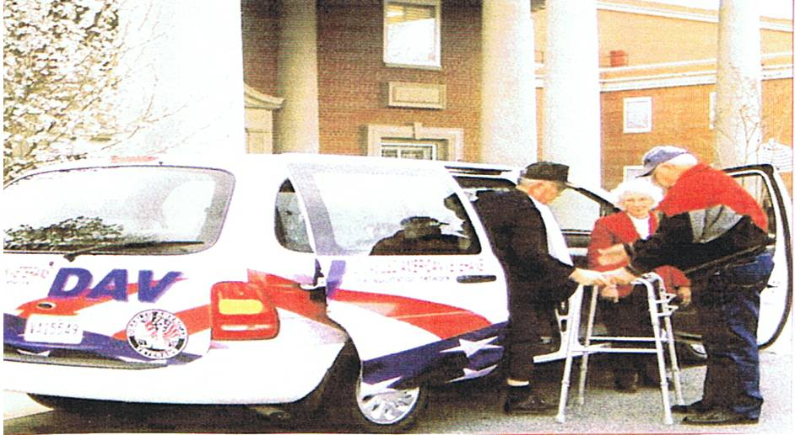

DAV, Dept of MD-Veteran of the Year
Chair – PDC Glynn E. Parker

Each year the DAV Department of Maryland selects an outstanding DAV member as Veteran of the year. The Department in turn forwards the recommendations to the Joint Veterans Committee of Maryland for selection as the Maryland Veteran of the Year. Each Chapter should forward the name of a DAV member to be considered for the Maryland Veteran of the Year. Please send in the names as soon as possible. The Name of the DAV Veteran of the year will be brought before the Convention in May. Let us hear from you soon. Note: All the recommendations should be sent to the Department Office.

The package should include:

- Name, address and telephone number.

- A strong recommendation supporting the award.

Remember in order to remain competitive; the recommendation should include military service, any other organizations to which the candidate is a member in addition to the DAV, i.e., Veteran Service Organization’s (VSO’s) such as the VFW and the American Legion. It is important to clearly state the candidate’s accomplishments. Consider work in other VSOs, and civic organizations, etc. Please include Chapters and/or Department offices the candidate has held.

Question may be sent to me or any member of the Veteran of the Year Committee.

Glynn E. Parker

VETERANS AFFAIRS VOLUNTEER SERVICES (VAVS)
Glynn E. Parker, VAVS Representative

I believe it is in order to congratulations all of our volunteers, Transportation Coordinators, HSC’s, and Drivers and anyone else volunteering in any capacity to aid and assist our veterans. My hats off to Chapters 13 and 21 for the recognition they gave their driver at their Installations a few days ago. I look forward to witnessing other volunteer being recognized for the hard work they do. Our hope is to continue to expand the transportation networks around the State by working closely with the VA in our efforts to assist veterans. The Department recently requested several new vans. I am told that they should be here later this year. We will listen to all suggestions. Thanks for your help.

Glynn E. Parker

Disabled American Veterans Auxiliary
Betty Swift, State Commander

Hi everyone,

Here it is time for another DEC/SEC meeting. Where does the time go?

I hope some of you were able to attend the Mid-Winter Conference in Washington, D.C. If not, read the legislative agenda in the DAV magazine. Contact your representatives to Support the programs that will affect our Veterans.

I have been notified by National that the Auxiliary representative at our State Convention will be the National Commander Sandy Dobmeier. I hope everyone will make her feel welcome, and show our hospitality that we have been noted for.

Since the last meeting I have attended many Christmas get-togethers. I also attended the Sixth District Meeting in Charlottesville, VA.

I have attended the VAVS Meetings at both the Baltimore and Perry Point V.A. Hospitals.

In November I attended the Veterans Information night program held at Chapter and Unit 26.

I am looking forward to seeing everyone at the DEC/SEC meeting on April 19, 2009, 12PM at the VFW Post 160, 2597 Dorsey Road, Glen Burnie, MD 21060.

E. Betty Swift
Auxiliary State Commander

DAVA

MAY THERE BE
PEACE ON EARTH
AND GOODWILL TO ALL PEOPLE



National Service Office
Baltimore, Maryland

My fellow Comrades,

Greetings from my office, Ron Minter (Assistant Supervisor), Krista Korbar (associate), Lamarr Couser (associate), Denise Duckett and Bob Cole (support staff).

We continue to provide service for our states disabled veterans and their families. I encourage you all to “get the word out” to all veterans and their families.

In today’s trying times with the economy doing so bad, we all know every dollar is more important than ever. How many veterans are out there in this great state not receiving VA benefits that should be? If there is one veteran or family member not receiving deserved compensation, then there is one too many! PLEASE speak up and get the word out! A simple “excuse me, but are you a veteran” could open the door to a whole new life for a veteran.

I have been excited with the great work our Chapter Service Officers (CSO) has been doing. In one chapter, the 2 CSO’s have coordinated with a VA clinic to allow them to have a room for interviews each month. They have another clinic they are working with for the same reason. The CSO’s know if we can’t be there to help them, we will be standing by for their call, should they have any questions. This is awesome! What a great example of a Chapter taking action to do something. Let’s follow their lead!

National Service Officer (NSO) trainee Lamarr Couser has officially finished his 16-month OJT training program and is now a full associate NSO. Congratulations to NSO Couser! That 16 month training program is no easy thing. It takes a lot of hard work, time, and dedication to meet all of DAV’s training requirements in those 16 months.

Mobil Service Office
If you already are working with the DAV, National Service Office, it is better to call the DAV, NSO Office at 410-230-4440. The MSO truck is out there to meet new people and will not be able to check on a claim or anything for those who already have pending claims.

Listed is the MSO schedule for this half of the year.

- April 11, Sat. Harley Dealership, Hughesville,
MD
- May 23, Sat. Harley Dealership, Ft. Washington
- June 16, Tuesday, Lexington, MD.
- June 18, Thursday, Westminster, MD. VFW Post
- June 23, Tuesday, Ocean City, MD. VFW Post
- June 25, Thursday, Del Mar, MD. VFW Post
- Sept. 8, Tuesday, Arlington, VA.
- Sept 9, Wed, Hagerstown, MD. VFW Post
- Sept. 10, Thursday, Lexington Park, MD.
- Sept. 19, Harley Dealership, Hughesville, MD.

There is nothing new to report concerning the National Guard program. Department 2nd Vice Commander Roundtree has done a great job in attending as many events as he could. This past year there has been many changes in how the Guard is received and processed home and how we fit in. We will have to do much work if we plan to keep it going.


CHAPTERS CORNER

Chapters, please send in pictures and articles of events that your Chapter attends so that they can be placed in future Newsletters or to be send to National for placement in the DAV magazine.

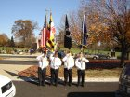

Chapter 13 Honor Guards at Crownsville Cemetery on Veterans Day.

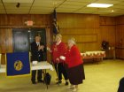
Chapter 13 Commander Pete Swartz recognizing Department Admin Asst. (Cookie) B. Iafolla and her friend Carol DuBritton, for their voluntary services at Golden Corral in Glen Burnie.

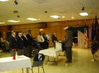
Department Commander, Gregory N. Jones, installing new officers of Chapter 13.
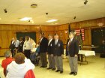
New Officers for Chapter 13 – Good Luck to all
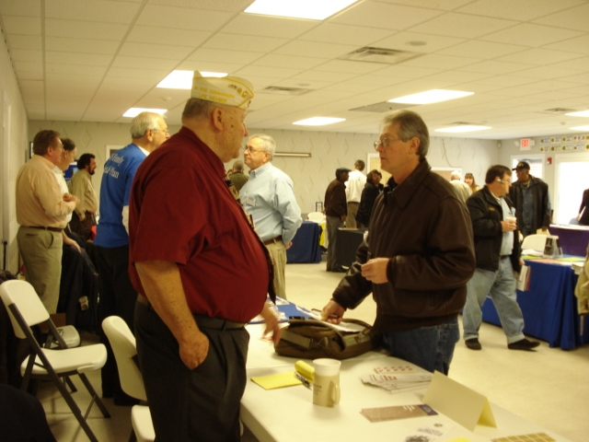
Veterans Muster in Salisbury (2/21/09), DAV Department, SVC Robert Wilcoxen (Chapter 26), hard at work helping a veteran.

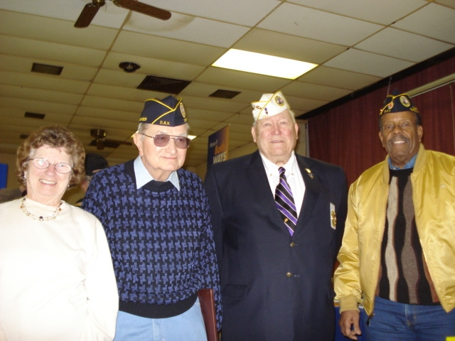
Veterans Muster in Dundalk (1/24/09) – DAV/DAVA Comrades: Lucy & Ray Davis, SVC Robert Wilcoxen & Ernie Law, they are out there helping veterans and their families.

READ ALL ABOUT IT…

From National Headquarters:

DISABLED VETERANS BENEFIT FROM ECONOMIC STIMULUS BILL
H.R. 1, the American Recovery and Reinvestment Act of 2009, contains provisions important to elderly, sick and disabled veterans. The stimulus bill approved an “Economic Recover Payment” to certain individual veterans – primarily those in receipt of disability compensation or nonservice-connected VA pension – of $250. The U.S. Treasury and the Secretary of Veterans Affairs are directed by the Act to identify recipients and make payments directly to them within 120 days of approval of the Act by the President, who signed the measure February 17. Application by individual veterans is not necessary for disabled veterans to receive this one-time payment.
H.R. 1 also provides over $1.4 billion in new funding for a variety of VA programs, especially VA health care-related facilities, as follows:
- $1 billion for maintenance improvements and upgrades to VA health care facilities
- $150 million in VA grant funds for State Veterans Home construction and restoration needs
- $200 million to improve disability claims processing and information technology in the VBA; and
- $50 million to restore and provide better upkeep for VA’s closed national cemeteries.

Veterans Health Care Funding Reform Bill Promises Transparency, Accountability

WASHINGTON, Feb. 12—The Disabled American Veterans today applauds the introduction of much-needed legislation that provides sufficient, timely and predictable funding for veterans health care and an unprecedented level of transparency and accountability to the budget process.

“The Veterans Health Care Budget Reform and Transparency Act is all about making government more efficient, transparent and accountable. These are three key elements that President Obama, Congress and veterans all agree are needed in these challenging times,” said DAV National Commander Raymond E. Dempsey. “Now, more than ever, it is absolutely imperative for Congress to end the old-style partisan politics of gridlock and reform the budget process to ensure that veterans, particularly sick and disabled veterans, have access to quality and timely health care,” he said. Dempsey praised the bill’s sponsors for their bipartisan commitment to America’s veterans. “We are grateful to the bill’s lead sponsors, Veterans’ Affairs Committee Chairman Daniel Akaka (Hawaii) and Sen. Olympia Snowe (Maine) in the Senate, and Veterans’ Affairs Committee Chairman Bob Filner (Calif.) and Rep. Walter Jones (N.C.) in the House. We also have the full support of Senator Tim Johnson (S.D.) and Rep. Phil Hare (Ill.), both of whom have led Congressional efforts for mandatory funding of veterans health care in prior Congresses, and are now backing this effort,” Dempsey said. Other cosponsors include Sens. Begich (Alaska), Bingaman (N.M.), Boxer (Calif.), Feingold (Wis.), Landrieu (La.), Lautenberg (N.J.), Menendez (N.J.), Murkowski (Alaska), Rockefeller (W.Va.), Sanders (Vt.), Stabenow (Mich.), Thune (S.D.) and Vitter (La.). Other House cosponsors include Reps. Michaud (Maine) and Herseth Sandlin (S.D.).

The measure would authorize Congress to approve VA medical care appropriations one year in advance of the start of each fiscal year, which would help end funding delays that have plagued VA when Congress has failed to pass appropriations bills on time. The legislation would also add needed transparency to the process by having the Government Accountability Office (GAO) review and report on the VA budget request. The advance appropriation legislation picked up bipartisan support after its introduction last year, including then-Senator Obama, who pledged during his Presidential campaign to request it in his first budget submission for fiscal year 2010.

“This sufficient, timely and predictable funding mechanism will allow the VA to work better and smarter in caring for our nation’s veterans, including those wounded in Iraq and Afghanistan,” said Dempsey. “This legislation will once and for all end the funding delays that for decades have threatened the VA’s ability to deliver timely, quality medical services to the nation’s sick and disabled veterans,” he said. The DAV and the eight other members of the Partnership for Veterans Health Care Budget Reform, along with a growing coalition of military and veterans groups, former VA officials and hospital directors, and an overwhelming majority of American voters, all support legislation to approve VA’s health care funding one year in advance.

The Partnership for Veterans Health Care Budget Reform (www.fundingforvets.org), which worked closely with the bill sponsors in drafting the legislation, is comprised of AMVETS, Blinded Veterans Association, Disabled American Veterans, Jewish War Veterans, Military Order of the Purple Heart, Paralyzed Veterans of America, The American Legion, Veterans of Foreign Wars and Vietnam Veterans of America.

The 1.2 million-member Disabled American Veterans is dedicated to building better lives for our nation’s disabled veterans and their families. For more information, visit the organization’s Web site, www.dav.org.
###
 The Maryland Veteran 

From Veterans Affairs:

Maryland Historical Society Exhibit
November 11, 2008 – December 31, 2009

The exhibition opening was celebrated during the Maryland Historical Society’s Veterans Day Commemoration Ceremony at which Governor O’Malley gave a tribute to World War II veterans.

Honoring combat veterans from Maryland, who served in every theater of the war, the exhibition displays uniforms, small arms, and equipment authentic to the men who used them often “personalized” with their own artistic touches. Helmets are inscribed with individual names and unit, and in some cases pierced by shrapnel and bullet holes, while weapons carry the dents and dings of active fighting from the Normandy beaches to Iwo Jima. The material in the exhibition comes primarily from the collection of Colonel (MD) George S. Rich.

The Maryland Historical Society is offering Complimentary Family Memberships to all World War II veterans throughout the run of the exhibition until December 31, 2009. For Information call 410-685-3750 or visit www.mdhs.org.

Free Mediation Services Helps Returning Veterans Re-connect
With Family and Community

Mediation can provide valuable assistance to reintegrate returning Maryland Veterans back into their families and communities. According to Pentagon data, nearly half of returning National Guard soldiers report some challenges, such as alcohol and/or drug abuse, excessive anger, sleeplessness and conflict with family members and coworkers. There are additional challenges for service members who have been severely wounded and face long and arduous recovery periods. That and the stress of combat as well as multiple deployments also create issues for service members, their families and employers.

Conflicts or tensions may occur for any of the following reasons:

- Returning veterans may well be exhausted and unable to resume their previous responsibilities in the family, and conflict can result when neither spouse feels that their needs are being met.

- The veteran may want to jump right back into his or her role within the family and may run into conflict if the other spouse has gotten used to managing things alone.

- Children may fear for their deployed parent’s safety as well as for themselves since they are made to function without the parent there. Because children may not understand their own emotions, they frequently act out in ways that cause more stress for themselves and their family. When deployed parent first returns home, everyone anticipates a return to normal, whatever that may mean to each of them, but their expectations may be very different from each others’,

All of the scenarios described above, as well as others, may be addressed through mediation with trained, neutral mediators to assist with creating understanding and resolving disputes. Mediation is available at no cost and at a time and place convenient to participants through Community Mediation Centers located throughout Maryland. To find a center near you, go to www.mdmediation.org or call 888-826-2262.

New Program Assists Veterans
Applying for Federal Jobs

The Civilian Personnel Advisory Center (CPAC) at Fort Meade offers a Veterans Employment Assistance Seminar the second Thursday of each month. All appointments are on a first come first serve basis. To receive information on: resume preparation through the Civilian Personnel On-Line (CPOL) website; Veterans Recruitment Appointments (VRA); Veterans Employment Opportunities Act (VEOA); and 30 Percent Plus Disabled Veterans employment opportunities contact CPAC at 301-677-6526.

To reserve a seat for the seminars please email Mr. Ty C. Guda, Human Resources Specialist at ty.guda.chandler@us.army.mil.

Veterans Memorial Museum
In Charles County

Charles County has established a committee to plan, construct and administer a Memorial Museum to honor Maryland Veterans of all wars. The museum will be located in southern Maryland; the 18,000 square foot building is currently being modified and renovated to accommodate the museum.

The Maryland Veterans Memorial Museum Committee, a 501(c)(3) organization, encourages all Veterans and Veterans Organizations to become part of the planning and development of this new museum.

For more information contact Cindy Keesee at 301-932-1900 or visit their website: www.mdvets.cc.

ENJOYABLE TIDBITS:
(Jokes, poems, Songs, stories, sayings, etc.)

Very Inspirational Song & Video by Keith Carradine
If you want to hear song w/video, see email address below:
http://www.bornagainamerican.org

When I heard this song and watched the video, I thought of all the veterans and their families of those who served in the past and those who are serving in our Armed Forces now, and especially those who paid the ultimate price for their service, for their country….for their families…and yes for me and anyone else who calls themselves American. God Bless them All!

We need to make sure Veterans & their families get what they need and deserve in benefits, in compensation, and yes and also the respect and gratitude they deserve from all those who share in the freedom and the dream of being an American.

BORN AGAIN AMERICAN

Just a workin’ man without a job
It got shipped off to China via Washington, D.C.
And I know I’m nothin’ special
But there are plenty more like me
Just the same
I thought I knew the rules of the game

I stood up for this country that I love
I came back from the desert to a wife and kids to feed
I’m not sayin’ Uncle Sam should give me what I need
My offer stands
I’ll pull my weight if you give me half a chance

I went up to a congressman and said to him “you know
Our government is letting people down”
He said he’d need a lot of help to buck the status quo
I said there is a bunch of us around

I’m a Born Again American, conceived in Liberty
My Bible and the Bill of Rights, my creed’s equality
I’m a Born Again American, my country ‘tis of me
And everyone who shares the dream from sea to shining sea

My brother’s welding chassis at the plant
He’s earning what our granddad did in 1948
While CEOs count bonuses behind the castle gates
How can they see,
When all they care about’s the do re mi.

It’s getting where there’s nowhere left to turn
Not since the crash of twenty-nine have things been so unfair
So many of our citizens are living in despair
The time has come
To reaffirm that hope’s not just for some

The promise of America’s surrendering to greed
The rule is just look out for number one
But brace yourself “cause some of us have sown a different seed”
A Harvest of the spirit has begun

I’m a Born Again American conceived in Liberty
My Bible and the Bill of Rights
My creed’s equality
A Born Again American, my country ‘tis of me
And everyone who shares the dream from sea to shining sea

It’s clear my country’s soul is on the line
She’s hungering for something that she lost along the way
The principle the framers called upon us to obey
That in this land
The people’s will must have the upper hand

I felt the calling once before and took a sacred vow
And faithful to that vow I have remained
I hear the calling once again, my country needs me now
And to her cause I have been re-ordained

I’m a Born Again American conceived in liberty
My Bible and the Bill of Rights, all people living free
A Born Again American, my country ‘tis of me
And everyone who shares the dream
From sea to shining sea

And everyone who shares the dream
From sea to shining sea

A M E R I C A





